EXPERIMENT 1
1.create table DEPARTMENT (id number(7), name varchar(25))
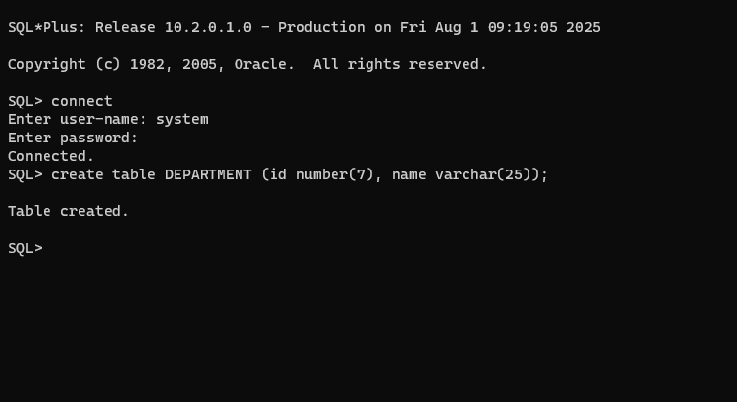
2.create table EMP (id number(7), last_name varchar(25), first_name varchar(25), dept_id number(7))

3.alter table EMPLOYEE modify(last_name varchar(50))

4.create table EMPLOYEE2 (employee_id number(7), first_name varchar(25), last_name varchar(25), salary number(10), dept_id number(7))
5.drop table EMPLOYEE


6.rename EMPLOYEE2 to EMPLOYEE

7.comment on table EMPLOYEE is 'this is a employee table'
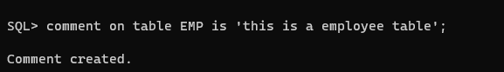
8.alter table EMPLOYEE drop column first_name


